PE Funding

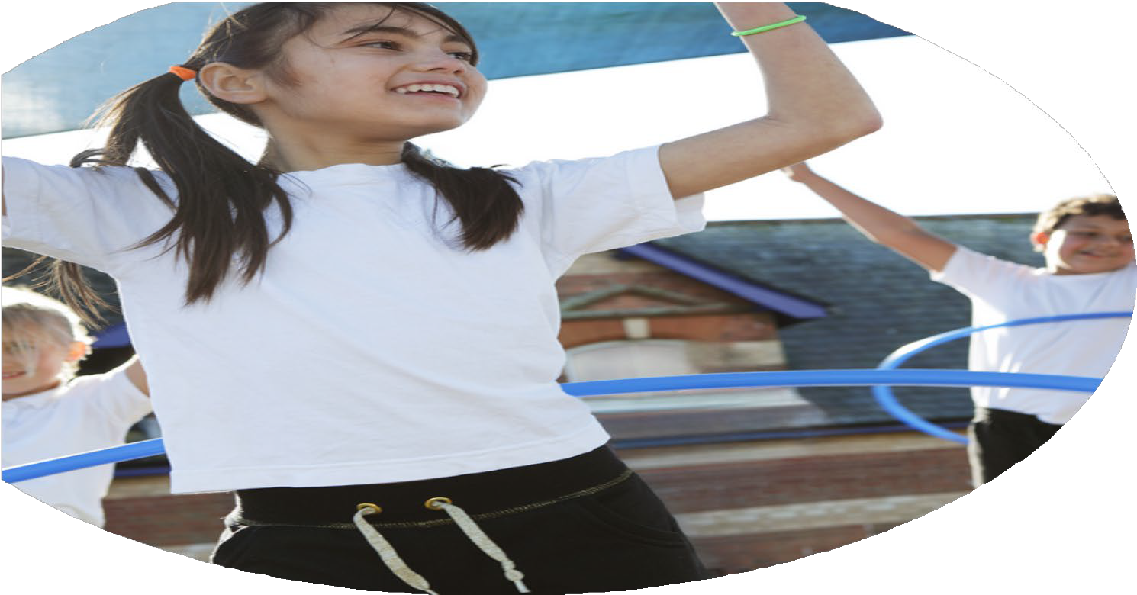

Evaluation Form

**Commissioned by**

**Created by**

Images courtesy of Youth Sport Trust

**PE Funding Evaluation Form**

 It is intended that this template should be used as preparation for the completion of the statutory digital reporting tool being introduced this academic year. You can upload data (including swimming) from this template onto this platform once it becomes accessible.

 Before you decide how you are going to use the funding for this academic year you should reflect and evaluate the impact of your use of the funding in 2023/24.

 All spending of the funding must conform with the terms outlined in the Conditions of Grant document.  The template is a working document that you can amend/update during the year.

 Based on your evaluation of last year’s funding you should decide what you intend to do this academic year, how you will do it, and what impact you expect it to have.

It is important that the funding is used effectively and based on your school’s needs.

 You must use the funding to make additional and sustainable improvements to the PE and sport in your school.  You must develop and add to the PESSPA activities that your school already offers.

*Summative digital reporting from June 2025 will continue to include swimming and water safety information therefore funding can be used to provide top-up lessons where necessary to ensure pupils meet national curriculum swimming requirements.*

**We recommend that you start by reflecting on the impact of current provision and reviewing your previous spend**

|  |  |  |  |
| --- | --- | --- | --- |
| What went well? | How do you know? | What didn’t go well? | How do you know? |
| All children across the school take part in the active 30 minutes each break and lunchtime.  Data shows attainment of boys raised in maths, literacy and reading in those targeted children.  60% of SEND pupils attended after school clubs. | After working with the SENCO to identify which children were less active, we purchased equipment based on a questionnaire given to the children. Staff at lunchtimes noticed more uptake in physical activity in those identified children.  Plan to continue this the following year and train new TAs in the delivery of sessions.  Continue to target these children next year. | Ensuring that all children went to at least one competition. | Swimming clashed with competition times so swimming has now been changed to a Friday. |

|  |  |
| --- | --- |
| What are your plans for 2024/25? | How are you going to action and achieve these plans? |
| Intent | Implementation |
| ***Promoting inclusive practice in class P.E lessons across the school by purchasing differentiated equipment.***  ***Use of PE mentor to work alongside new members of staff to increase confidence and competence to deliver high quality PE.***  ***Use Youth Activators to use sport to raise activity levels of all children across the school.***  ***Increase the variety of after school clubs available to children across the school.***  ***Use Activators to raise the profile of PESSPA in Early Years.***  ***Provide adequate time and resources for staff to engage with the schools P.E curriculum/scheme (Get Set 4 P.E) so they know and understand what is to be taught.***  ***To increase participation in competitive sport throughout the year.***  ***Promoting inclusive practice in class P.E lessons across the school by purchasing differentiated equipment.***  ***Use of PE mentor to work alongside new members of staff to increase confidence and competence to deliver high quality PE.***  **Embed school games values throughout P.E lessons. Making sure children receive dojo points for social, emotional and thinking not just P.E skills. A P.E board will be set up in the hall and children will awarded a certificate with their name on after each lesson based on the value they have demonstrated. These can also be put on class dojo.** | *Youth activators lunchtime clubs now carried on by Young Leaders at playtimes. Children report being more active at lunchtimes.*  *Football club, tennis club, dance club, multi-sports club, cricket, girls clubs. Questionnaire show children would like the clubs to continue next year and data on GetSet4P.E shows high percentage of children participating in clubs.*  *All Early Years children took part in fun physical activities for 1 hour each week. Photos and pupils voice collected show the children now more engaged in being active. Staff now aware of offering a wider variety of activities.*  *Teaching staff report a great knowledge and understanding of the curriculum/ scheme, resulting in improved percentages of pupil attainment in P.E.*  *Calendars and school P.E book show a class from each year group taking part in a competition with other schools in our partnership. Pupil voice shows children engaging positively in the competitions. Children in Year 3-5 reached the finals of their athletics and sports hall tournaments.*  *All children have been observed participated for longer in class P.E lessons as they now have the correct equipment to engage and challenge them. All children have access to their own equipment and do not need to share resources.*  *Those staff who worked with the PE mentor reported increased confidence and competence to deliver HQ PE. Lesson observations by P.E lead show high quality P.E.* |

|  |  |
| --- | --- |
| What impact/intended impact/sustainability are you  expecting? | How will you know? What **evidence** do you have or  expect to have? |
| **P.E board will show names of a children from each class that have achieved each value each term. They will be collected in and given out in assembly at the end of each short term.**  **Also collect pupil voice.**  **Raise the profile of intra house competitions so at the end of each unit or before a competition children are demonstrating the skills and values they have learnt in that unit.**  **Ensure in staff meetings teachers are aware of how they can plan intra house competitions. Use Lucie P.E mentor to support staff with planning intra house competitions.**  **Class teachers to set up their new classes on GetSet4P.E. Assess children after each unit using the tools on GetSet4P.E.** | Staff questionnaires and intervention timetables show increase in staff confidence and increase in attainment.  Club lists show which children took part in P.E clubs.  Early Years children have signed up to the Early movers program.  Data from NOSSP shows which groups were targeted this year.  **Pupil voice and photos in P.E book. Staff have been asked to rag rate their subject knowledge using green and red colours against the units of work that they teach. Lucie will then ask again at the end of the unit she has peer taught with that member of staff.** |

|  |  |
| --- | --- |
| What **impact/sustainability** have you seen? | What **evidence** do you have? |
| Children are now able to articulate their own personal development in P.E.  Staff are now more confident to teach certain units in P.E as identified in their questionnaires before and after working with P.E mentor. | **Assessment data on GetSet shows progress made each term and which children and key groups have been targeted or need to be targeted further**  **Pupil voice.**  **Photos in P.E book.**  **Completed staff questionnaires.**  **Lesson observation forms.** |