St Joseph’s School Menu Winter 2023
Week One  30 Oct/20 Nov/11 Dec |  | Week Two  6 Nov/27 Nov/18 Dec |  | Week Three  13 Nov/4 Dec
Monday  Pepperoni pizza 2, 7  Cheese and tomato pizza 2, 7  Spiral pasta, sweetcorn, salad bar 2, 7  Fresh fruit, yoghurts 7  Tuesday  Mexican chicken  Rainbow noodles 2, 4  Rice, peas, carrots, salad bar, naan bread 2  Fresh fruit, yoghurts 7  Wednesday  Butchers’ beefburgers in soft rolls 2, 14  Vegetarian fingers 2  Spicy wedges, baked beans, sweetcorn, salad bar  Fresh fruit, yoghurts 7  Thursday  Toad-in-the-hole 2, 4, 7  Cauliflower cheese 2, 7  Roast potatoes, farmhouse vegetables, gravy 2, 14  Fresh fruit, yoghurts 7  Friday  Breaded fillet-of-fish 2, 5  Cheese and onion pasties 2, 7  Chunky chips, spaghetti hoops, peas, salad bar 2  Fresh fruit, chocolate cookies 2, 4, 7, 10, 13 |  | Monday  Chicken goujons with barbecue sauce 2, 13  Vegetarian quorn sausage 2, 4, 7, 13  Spicy wedges, sweetcorn, broccoli, salad bar 2  Fresh fruit, yoghurts 7  Tuesday  Meatballs in a tomato sauce with pasta 2  Cheese and tomato pasta 2, 7  Pasta, peas, carrots, garlic bread, salad bar 2, 7  Fresh fruit, yoghurts 7  Wednesday  Sweet and sour chicken  Savoury noodles 2, 4  Rice, sweetcorn, naan bread, salad bar 2, 7  Fresh fruit, yoghurts 7  Thursday  Roast pork with Yorkshire pudding 2, 4, 7  Vegetable medley cheese bake 2, 7  Roast potatoes, farmhouse vegetables, gravy 14  Fresh fruit, yoghurts 7  Friday  Breaded fillet-of-fish 2, 5  Cheese and onion pasties 2, 7  Chunky chips, spaghetti hoops, peas, salad bar 2  Fresh fruit, gingerbread men 2, 4, 7, 13 |  | Monday  Gammon with pineapple  Macaroni cheese 2, 7  Spicy wedges, sweetcorn, carrots, salad bar 2  Fresh fruit, yoghurts 7  Tuesday  Spaghetti bolognese 2  Vegetable grills 2, 4, 7, 13  Pasta, peas, broccoli, garlic bread, salad bar 2, 7  Fresh fruit, yoghurts 7  Wednesday  Butchers’ finest sausages with gravy 2  Red pepper and tomato pasta 2  Mashed potatoes, sweetcorn, salad bar 7  Fresh fruit, yoghurts 7  Thursday  Roast chicken with Yorkshire pudding 2, 4, 7  Cauliflower and broccoli cheese 2, 7  Roast potatoes, farmhouse vegetables, gravy 14  Fresh fruit, yoghurts 7  Friday  Breaded fillet-of-fish 2, 5  Cheese and onion pasties 2, 7  Chunky chips, spaghetti hoops, peas, salad bar 2  Fresh fruit, artic roll 2, 7
Gluten/dairy free options available  Fresh seasonal veg, salad and bread available |  | Gluten/dairy free options available  Fresh seasonal veg, salad and bread available |  | Gluten/dairy free options available  Fresh seasonal veg, salad and bread available
Autumn 2023
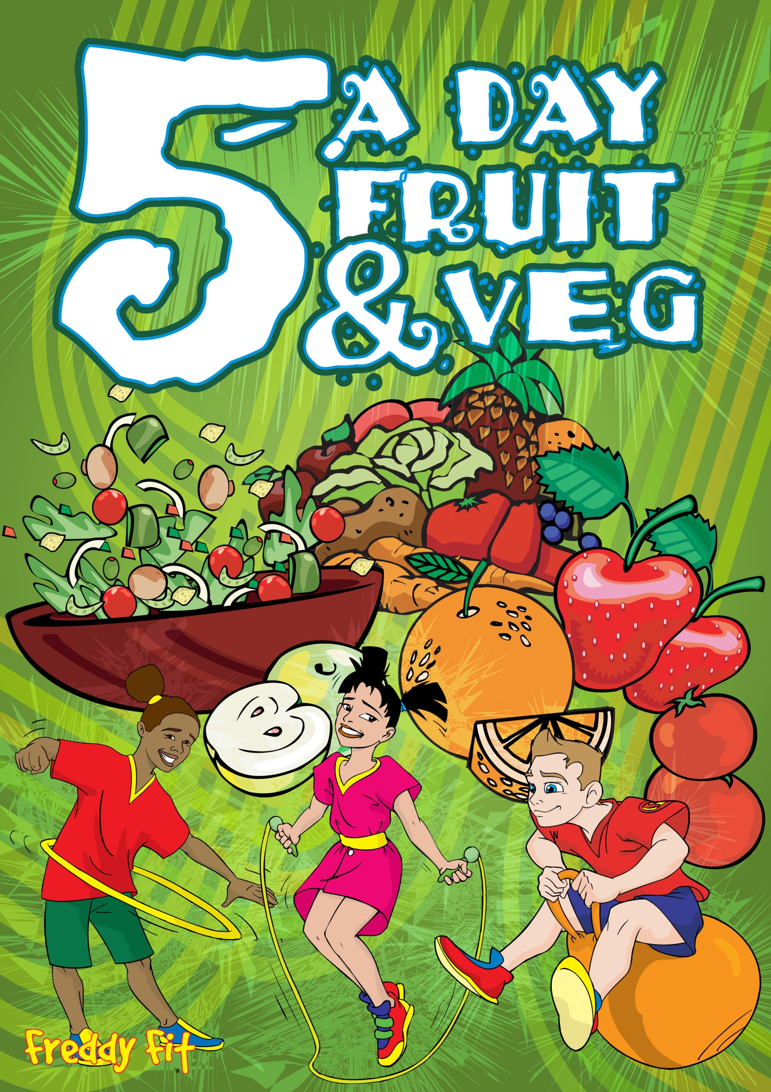  St Joseph’s School  Menu  Winter 2023 |  | Allergens Key |  | Balanced  Good Quality  Nutrition  Compassion Respect Truth  Service Forgiveness  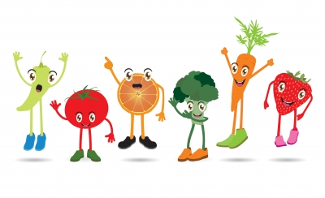
 |  | 1 Celery  2 Cereal containing gluten  3 Crustaceans  4 Eggs  5 Fish  6 Lupin  7 Milk  8 Molluscs eg fish/snails/ squid/whelks/oysters  9 Mustard  10 Nuts  11 Peanuts  12 Sesame seeds  13 Soya  14 Sulphur dioxide | Blessed George Napier Catholic School

